Integrated Security System (ISS)
For
Sentosa Development Corporation (SDC)

Functional Requirements Document (FRD)
No Objection Permit
(Version 0.5)

 |  | Name | Designation / Company | Signature
Prepared By | : | Wong Shin Feng | Business Analyst (SJ)
Reviewed By | : | Gan Kian Teck | Application Lead (SJ)
Reviewed By | : | Valerie Shao | Project Manager (NCS)
Approved By | :

Table of Contents
1. Document Control 5
1.1 Version History 5
1.2 Definitions, Abbreviations, Acronyms 5
2. User Roles and Permissions 7
2.1 Role Definitions 7
3. NOP Overview 8
3.1 High Level NOP Process Flow 8
3.2 NOP Reference Number 8
3.3 NOP Status and Validity Model 8
3.3.1 Application Status 9
3.3.2 Approval Status 10
3.3.3 Permit Validity State 10
3.3.4 Permit Operational State 11
3.3.5 Status Transition Rules 11
3.4 NOP Duration Categories 12
4. Application Submission 13
4.1 Access to NOP Application 13
4.2 NOP Application Form Fields 13
4.2.1 NOP Applicability and Scope 13
4.2.2 NOP Work Involvement 13
4.2.3 Applicant and Liaison Officer Details 14
4.2.4 Emergency Contact Details 15
4.2.5 Project and Work Schedule 15
4.2.6 High-Risk Work, Equipment and Vehicles 16
4.2.7 Location of Works 17
4.2.8 Personnel On-site 18
4.2.9 Remarks and Declaration 18
4.3 Application Submission Rules 18
4.3.1 Supporting Document Schedule 18
4.3.2 Conditional Document Contents 20
4.3.3 Attachment Upload Rules 21
4.4 Map and Boundary Marking 22
4.5 Draft Save and Retrieval 22
4.6 Urgent NOP Classification 22
5. Approval Workflow 23
5.1 Approval Actions 23
5.2 Parallel Approval 23
5.3 Approver Assignment and Approval Continuity 23
5.4 Approval Routing Availability 24
5.5 Routing on Resubmission 24
5.6 Approval Matrix 24
5.7 Information Presented to Applicant 25
6. NOP Lifecycle Management 26
6.1 Permit Validity and Expiry 26
6.2 NOP Extension 26
6.3 Suspension, Cancellation and Revocation 26
6.4 Blackout Dates 27
6.5 Urgent NOP Document Completion 27
6.5.1 Document Completion and Permission to Work 27
6.5.2 Overdue Documents and Completion 27
7. NOP Register and Reporting 28
7.1 NOP Register 28
7.2 Approver Application Views and Access 28
7.3 NOP Register Export 28
8. Notifications 29
8.1 Notification Matrix 29
8.2 Email Delivery 31
8.3 Approval Reminders and Escalation 31
8.4 Notification Configuration 32
9. UCS Integration 33
9.1 UCS Dashboard and Navigation 33
9.2 UCS Map View 33
10. Non-Functional Requirements 34
11. Dependencies 36
12. Open Items 37
12.1 Approval Matrix 37
12.2 Contractor CMS Account Setup 37
12.3 Urgent NOP Document Completion 37
12.4 Overdue Urgent NOP Consequence 37
12.5 Authorised Lifecycle Roles 37
12.6 Applicant Approval Visibility 37
13. Appendix 38
13.1 Fault Types and Sub-types 38

Document Control

Version History
Version | Date | Description
0.1 | 11 June 2026 | Initial draft
0.2 | 19 June 2026 | Added Approval Status table, added High-Risk Work, Equipment and Vehicles to NOP Work Involvement (renamed from NOP Type)
0.3 | 1 July 2026 | Comments from ISFM
0.31 | 20 July 2026 | Revised Section 4.2 - 4.6 on NOP application form, Urgent NOP workflow and review corrections.  Revised some items in Section 5 on Approval Actions and Routing  Added Section 7 on NOP Register, approver views and summary export  Updated Open Items questions
0.4 | 6 Aug 2026 | Added Roles Action matrice, updates stakeholders description, LO details, permit statuses and transitions, group approval assignments
0.5 | 6 Sept 2026 | Revised NOP roles and permissions, Liaison Officer pre-screening, IPA and document completion rules, lifecycle workflows and notifications. Added updated process diagrams.

Definitions, Abbreviations, Acronyms
Term | Definition
2FA | Two-Factor Authentication
AD | Active Directory
BAU | Business As Usual
CMS | Case Management System
CMMS | Computerised Maintenance Management System
DM | Duty Manager
DO | Duty Officer
FRD | Functional Requirements Document
HOTO | Handover and Takeover
IIOC | Island Integrated Operations Centre
IFM | Integrated Facilities Management
IOH | Integrated Operations Hub
ISS | Integrated Security System
LO | Liaison Officer
MOS | Method of Statement
NCS | NCS Pte Ltd
NOP | No Objection Permit
OR Team | Operational Resilience Team
OTP | One-Time Password
PTW | Permit to Work
RA | Risk Assessment
RBAC | Role-Based Access Control
SDC | Sentosa Development Corporation
SJ | Surbana Jurong
UCS | Unified Command System
WOG SSO | Whole-of-Government Single Sign-On

User Roles and Permissions

Account Access
- Access to the NOP modules requires an authenticated user account.
- Available functions and access to records are determined by the user’s assigned NOP roles and permissions.

Role Definitions
The following table defines the roles within the NOP module. A user may hold more than one authorised NOP roles.
Role | Description
NOP Business Owner | Sets NOP policies and appoints the NOP Operations Admin to execute.
NOP Operations Admin | Manages the NOP module, users, maintains approval routing and submitted applications, including approval and lifecycle actions.
Stakeholder Manager | Manages users and their permitted roles within their own organisation.  May also act as an Applicant, Liaison Officer or Approver when authorised.
Applicant | Creates and submits NOP applications, provides supporting documents and responds to requests for changes.  May withdraw applications or request extension, cancellation or lifting of suspension where permitted.
Liaison Officer / Supervisor | Screens assigned applications and related requests before sending them for approval.  Returns incomplete or unclear submissions to the Applicant for correction. Does not edit or approve the same application.
Approver | Reviews applications and requests assigned to them and decides whether to approve or request changes.  May suspend, revoke or lift suspension of NOPs where authorised.
Duty Manager | Coordinates requests for in-principle approval with the relevant stakeholder Approvers.
SDC Stakeholder / Operational Viewer | Views NOP information to coordinate operations, identify conflicting works and support planning. Includes the Operational Resilience Team where applicable.
System Administrator | Provides technical support for the CMS platform. Day-to-day NOP administration is handled by the NOP Operations Admin.

NOP Role Relationships and Actions
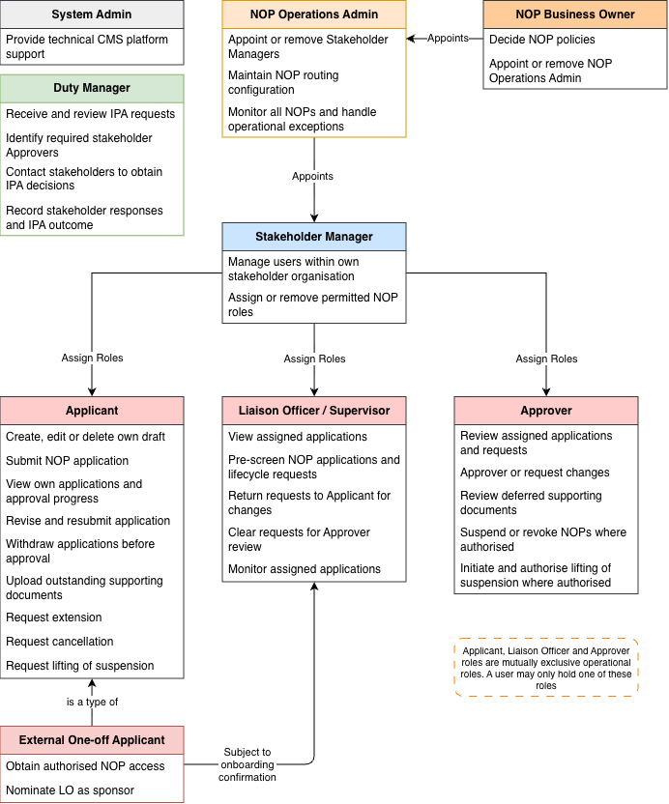

Role Permissions
Permissions apply to the user’s assigned roles and their involvement in each NOP.

Application Status and Roles Actions Matrix
Application Status | Applicant | Liaison Officer | Approver | SDC Stakeholder | NOP Operations Admin
Draft | - Create  - View  - Edit  - Delete  - Submit | No access | No access | No access | No access
Under Review | - View own application  - Request withdrawal | - View assigned application  - Pre-screen  - Request changes  - Clear for approval | - View assigned application  - Approve or request changes | View authorised applications | Full Access
Change Requested | - View own application  - Amend  - Request withdrawal  - Resubmit | - View assigned application  - Review comments | - View assigned application & previous decisions | View authorised applications | Full Access
Approved | - View own application  - Upload deferred documents | View assigned application | - View assigned application  - Review deferred documents | View authorised applications | Full Access
Withdrawn | View withdrawn application | View assigned application | View assigned application | View authorised applications | Full Access

Permit Status and Role Actions Matrix
Permit Status | Applicant | Liaison Officer | Approver | SDC Stakeholder | NOP Operations Admin
Upcoming | - View own NOP  - Request extension  - Request cancellation  - Upload deferred documents | - View assigned NOP  - Pre-screen extension and cancellation requests  - Request changes to requests  - Clear requests for approval | - View assigned NOP  - Approve or request changes to extension and cancellation requests  - Review assigned deferred documents  - Revoke | View authorised NOPs | Full Access
Active | - View own NOP  - Request extension  - Request cancellation  - Upload deferred documents | - View assigned NOP  - Pre-screen extension and cancellation requests  - Request changes to requests  - Clear requests for approval | - View assigned NOP  - Approve or request changes to extension and cancellation requests  - Review assigned deferred documents  - Suspend or revoke | View authorised NOPs | Full Access
Suspended | - View own NOP  - Request extension  - Request cancellation  - Request lifting of suspension  - Upload deferred documents | - View assigned NOP  - Pre-screen extension, cancellation and lifting-of-suspension requests  - Request changes to requests  - Clear requests for approval | - View assigned NOP  - Approve or request changes to extension and cancellation requests  - Review assigned deferred documents  - Initiate or authorise lifting of suspension  - Revoke | View authorised NOPs | Full Access
Expired | - View own NOP  - Upload deferred documents | - View assigned NOP | - View assigned NOP | View authorised NOPs | Full Access
Cancelled | View own NOP | View assigned NOP | View assigned NOP | View authorised NOPs | Full Access
Revoked | View own NOP | View assigned NOP | View assigned NOP | View authorised NOPs | View all NOPs

NOP Overview

High Level NOP Process Flow
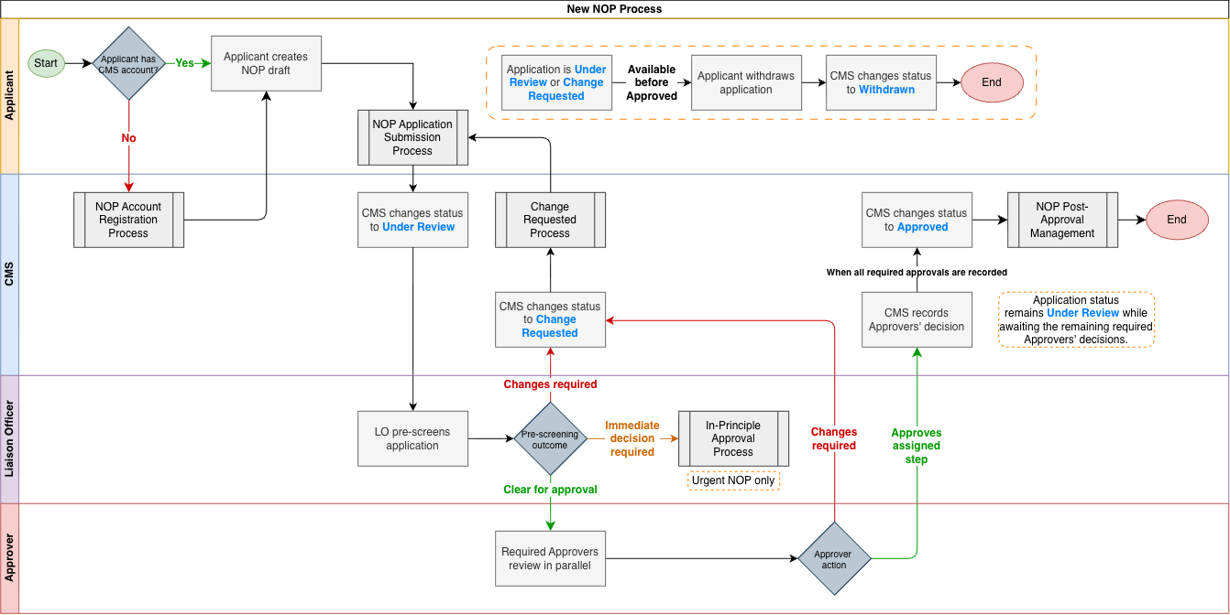

NOP Reference Number
Upon successful submission, each NOP application shall be assigned a system-generated reference number in the format SEN/NP/YYYYMMDD/NNN.
Component | Description
SEN | SDC prefix
NP | No Objection Permit identifier
YYYYMMDD | Date of successful submission
NNN | Sequential counter, zero-padded to three digits and reset daily
Example: SEN/NP/20260603/001

NOP Status and Validity Model
Each NOP shall maintain:
- An Application status showing its approval or lifecycle stage
- An Approval status for each required approval step
- A Permit status showing whether an issued NOP is Upcoming, Active, Suspended, Expired, Cancelled or Revoked
- An IPA status showing the outcome of a request for permission to start urgent work before full NOP approval
- An audit history of application, approval and lifecycle actions

Application Status
Status | Description | Actor
Draft | Application created but not yet submitted | Applicant / System
Under Review | Application successfully submitted and awaiting one or more required review or approval actions | Applicant
Change Requested | Additional information or amendments have been requested by the LO or Approver.  The applicant is informed on the request for revision, and resubmits the existing application.  Reference number and audit history are preserved. | Liaison Officer / Approver
Approved | All required approvers have approved, and the NOP has been issued. | System
Withdrawn | Application withdrawn by the applicant. | Applicant

Approval Status
Approval Status | Description | Actor
Pending Approval | Approver is required for the application and has not yet taken action | System
Change Requested | Required Approver has requested amendments or additional information from the applicant | System
Approved | Approver has approved application for their assigned area of responsibility | System

Permit Status
Permit State | Description | Actor
Upcoming | Approved NOP with a validity start date later than the current date and time. | System
Active | Approved NOP where the current date and time falls within the approved validity period. | System
Suspended | Work is temporarily prohibited under an approved NOP. NOP validity period continues to elapse. | Authorised SDC role
Expired | Approved NOP where the validity end date and time has elapsed. | System
Cancelled | An approved NOP terminated following an applicant cancellation request and confirmation by an authorised SDC role. | Authorised SDC role
Revoked | Approved NOP that has been permanently revoked by an authorised SDC role. Work is no longer permitted under the NOP and cannot be reinstated. | Authorised SDC role

In-Principal Approval Status
- In-principal approval is tracked separately from the NOP Application status.
- Granted IPA authorises work within the NOP’s recorded period and conditions.
- The Applicant completes and submits the full NOP application with all required documents by the configured document-completion deadline.
- The default period is 3 calendar days from IPA being granted.
IPA Status | Description
Pending | IPA has been requested and awaits the required Approvers’ decisions.
Granted | All required IPA approvals have been recorded. Work may start within the authorised period and conditions.

Status Transition Rules
Status Area | From | To | Trigger | Actor
NOP Application | Draft | Under Review | Application submission validated and the application is submitted | Applicant / System
NOP Application | Under Review | Change Requested | An authorised reviewer requests amendments or additional information | LO / Approver
NOP Application | Change Requested | Under Review | Applicant amends and resubmits the existing application | Applicant
NOP Application | Under Review | Approved | All required approvers approve; the NOP is automatically issued | System
NOP Application | Under Review / Change Requested | Withdrawn | Applicant withdraws application | Applicant
Permit | Upcoming | Active | NOP validity start date reached | System
Permit | Active | Suspended | Authorised SDC role issues suspension of Permit | Authorised SDC role
Permit | Suspended | Active | Authorised SDC role lifts suspension of permit | Authorised SDC role
Permit | Upcoming / Active / Suspended | Expired | NOP validity end date reached | System
Permit | Approved permit | Revoked | Authorised SDC role permanently revokes the issued NOP | Authorised SDC role
Permit | Approved permit | Cancelled | All required cancellation approvals are obtained | Authorised SDC role

NOP Duration Categories
Each NOP shall be assigned a duration category for validating its requesting validity period. This category is separate from the Work Involvement(s) used for approval routing.
NOP Category | Description | Maximum Permit Duration
BAU Maintenance | Routine, recurring maintenance activities forming part of standard facility management operations | 3 - 6 months
Ad-hoc Work | Non-routine, one-off works outside a formally scoped project | 3 - 6 months
Project Work | Works forming part of a formally scoped and contracted project | Up to 3 years, aligned with the contract period

Application Submission

Access to NOP Application
- Applicants require an authenticated user account to create or submit an NOP application
- Applicants use their own accounts to create and submit NOP applications and to view their current and past application details, statuses and approval progress.
- Contractor accounts shall be restricted to the NOP module and the functions required for NOP application submission and tracking, unless the account is assigned other authorised CMS roles.

- The applicant shall nominate an SDC Sponsor, or Liaison Officer, for the NOP application, and include their details as part of the application.

NOP Application Form Fields

NOP Applicability and Scope
Field | Type | Mandatory | Notes
Work Involvement(s) | Multi-select checkboxes | Yes | Applicant shall select applicable NOP-triggering work scopes from the NOP Work Involvement checklist
Other Work Details | Free text | Conditional | Required when Others is selected under Work Involvement

NOP Work Involvement
Work Involvement | Validation / Notes
Works within 6 metres of the Sentosa Express Track protection zone
Works within 7.5 metres of the Sentosa Intra Island Cableway protection zone
Works requiring more than 1 hour at a single SDC-managed location, excluding Island Partner premises, Sentosa Golf Club and Sentosa Cove
Works requiring partial or full closure of a lane or road on Sentosa, including Sentosa Gateway | Traffic Management Plan becomes mandatory
Works involving a change in land level exceeding 1.5 metres
Vegetation removal or earthworks covering more than 2,000 square metres
Removal of trees with a girth exceeding 1 metre
High-Risk Work, Equipment and Vehicles
Confined Space Work
Working at Height Above 30 Metres | Scaffolding Involved becomes mandatory
Temporary Works Along the Seafront | PE-Endorsed Lateral-Load Calculations mandatory
Excavation Work | Excavation Depth input mandatory
Retaining Wall Work
Others

Applicant and Liaison Officer Details
Field | Type | Mandatory | Notes
Applicant Name | Account-derived | Yes | Populated from the Applicant’s authenticated user account.
Company | Account-derived | Yes | Registered company associated with the applicant's user account  Auto-populated as part of account creation for application
Mobile | Account-derived | Yes | Auto-populated as part of account creation for application
Email | Account-derived | Yes | Auto-populated as part of account creation for application
SDC Sponsor / Liaison Officer | Staff lookup | Yes | Email and/or other identification (department/agency) to be displayed to better distinguish users with same name  Applicant cannot select themselves as the Liaison Officer for the same NOP
SDC Sponsor Email | System-derived | Yes | Populated from selected Sponsor / Liaison Officer’s NOP user account. Not editable by the applicant
LO Mobile | System-derived | Yes | Populated from selected Sponsor / Liaison Officer’s NOP user account. Not editable by the applicant

SDC Sponsor / Liaison Officer Validation
- The Sponsor / Liaison Officer lookup in the NOP application shall validate against active NOP user accounts assigned the SDC Sponsor / Liaison Officer role
- The lookup will not query WOG AD directly.
- System shall prevent submission unless application selects an active NOP user account assigned the SDC Sponsor / Liaison Officer role.
- If no matching Sponsor / Liaison Officer account is found, the system shall inform the applicant that a valid account must be selected before submission.

Emergency Contact Details
Field | Type | Mandatory | Notes
Emergency Contact Name #1 | Text | Yes
Emergency Contact Mobile #1 | Text | Yes
Emergency Contact Name #2 | Text | No
Emergency Contact Mobile #2 | Text | Conditional | Required when Emergency Contact Name #2 is entered.

Project and Work Schedule
Field | Type | Mandatory | Notes
Project Title | Free text | Yes | Title of the proposed works.
Work Description | Free text
NOP Category | Dropdown | Yes | BAU Maintenance, Ad-hoc Work or Project Work
Validity Start Date | Date | Yes | Requested work start date. Start dates fewer than 7 calendar days from submission shall be classified as Urgent
Validity End Date | Date | Yes | Validated against the maximum duration for the selected NOP category.
Daily Work Start Time | Time | Yes
Daily Work End Time | Time | Yes
Working on Blackout Dates | Yes / No | Yes | When the requested work dates and location overlap with a blackout period and area, the Applicant receives a warning and indicates whether the application includes work during that blackout
Blackout Dates Work Reason | Free text | Conditional | Required when Working on Blackout dates is Yes
Night Work | Yes / No | Yes | Applicant indicates whether work will be performed at night.
Night Work Reason | Free text | Conditional | Required when Night Work is Yes.
Night Work Terms and Conditions Agreement | Checkbox | Conditional | When Night Work is Yes, the applicable warning shall be displayed and acknowledged before submission.
Urgent Indicator | System | System | Automatically set when the requested work start date is fewer than 7 days after that application date.

High-Risk Work, Equipment and Vehicles
Field | Type | Mandatory | Notes
Confined Space | Yes / No
Scaffolding Involved | Yes / No | Conditional | Required when Working at Height Above 30 Metres is selected.
Excavation Depth (metres) | Number | Conditional | Required when Excavation Work is selected.
Lifting Operations Involved | Yes / No | Yes | Determines whether the Lifting Plan and Critical Operations Submission is required.
Equipment Type | Multi-select dropdown | Yes | e.g. Crane and Excavator
Other Equipment Details | Free text | Conditional | Required when the applicable Other equipment option is selected.
Type of Vehicle | Dropdown | Yes

Location of Works
Field | Type | Mandatory | Notes
Location Tags | Map-generated or selected tags | Yes
Location on Map | Map selection / geometry | Yes
Road | Text / location-derived | Yes
Building - Common Name | Text / location-derived | Yes
Building - Postal Code | Text / location-derived | Yes
Level | Text | Yes
Space | Text | Yes | Unit number, room number, corridor, loading bay, lift lobby, etc.
Proposed Site Photo | Image upload | No

Personnel On-site
Field | Type | Mandatory | Notes
Workers List | Upload or repeatable entry | Yes | Name, NRIC/FIN, trade or occupation, employer company and work permit number
Person in Charge - Name | Text | Yes
Person in Charge - Mobile | Text | Yes
Person in Charge - Office Number | Text | No

Remarks and Declaration
Field | Type | Mandatory | Notes
Remarks | Free text | No
Privacy Policy Agreement | Checkbox | Yes

Application Submission Rules
- An NOP application shall be eligible for submission only after all fields marked Mandatory and all applicable conditional fields have been completed.
- Upon successful submission, each NOP application shall be assigned a unique reference number in the format SEN/NP/YYYYMMDD/NNN.
- The selected Validity End Date shall remain within the maximum duration permitted for the selected NOP Category.
- If the permitted duration is exceeded, submission shall be prevented and the applicant shall be informed of the applicable limit.

Supporting Document Schedule
The following schedule defines the supporting documents associated with an NOP application. The Requirement classification applies to the completed NOP record.
Document Groups | Supporting Document | Requirement | Trigger or Condition
Baseline Documents | Risk Assessment Form | Mandatory | All NOP applications
Baseline Documents | Method Statement, including Scope of Works | Mandatory | All NOP applications
Baseline Documents | Detailed Location Plan | Mandatory | All NOP applications
Approval Matrix Conditional Documents | Equipment and Personnel List | Conditional
Approval Matrix Conditional Documents | Stakeholder Coordination Documents | Conditional
Approval Matrix Conditional Documents | Regulatory Compliance Evidence | Conditional
Road Closure | Traffic Management Plan | Conditional | Partial or full closure of a lane or road on Sentosa, including Sentosa Gateway, is selected
Scaffolding Involved | PE-Endorsed Calculation Documents for Working at Height | Conditional | Working at Height Above 30 Metres is selected and Scaffolding Involved is Yes
Seafront Works | PE-Endorsed Lateral-Load Calculations Documents for Temporary Works Along the Seafront | Conditional | Temporary Works Along the Seafront is selected
Excavation Works | C&S PE Documentation for Excavation Work | Conditional | Excavation Work is selected
Excavation Works | Geotechnical PE Documentation | Conditional | Excavation Work is selected and Excavation Depth exceeds 6 metres.  Document is additional to C&S PE Documentation
Lifting Operations | Lifting Plan and Critical Operations Submission | Conditional | Lifting Operations Involved is Yes
Optionals | Environment Consultation Form | Optional
Optionals | URA/MND Written Directions | Optional
Optionals | Approved EIA Report | Optional
Optionals | Approved EMMP Inception Report | Optional
Optionals | Other Relevant Authority Approval or Permit | Optional
Optionals | Work Schedule | Optional | Where provided by the applicant
Optionals | Others | Optional | The applicant elects to provide additional supporting information

Conditional Document Contents
Submission | Documents
Lifting Plan and Critical Operations Submission | - Lifting Plan  - Calculations, site and access details  - Safe Work Procedure covering critical operations  - Professional Engineer endorsement where applicable
Equipment and Personnel List | - Applicable certificates  - Valid licences  - Equipment permits  - Registered inspector or Qualified Person endorsements  - Training records
Stakeholder Coordination Documents | - Stakeholder notifications  - Emergency contacts  - Emergency Response Plan
Regulatory Compliance Evidence | - Applicable Workplace Safety and Health (WSH) or Building and Construction Authority (BCA) approvals  - Professional Engineer endorsement  - Licensed Electrical Worker endorsement  - Insurance documents including public liability insurance

Attachment Upload Rules
- Each supporting document classified as Mandatory in the Supporting Documents Schedule shall have a labelled upload field identified as Mandatory.
- When the trigger for a Conditional supporting document is met, the CMS shall display the corresponding labelled upload field, identify it as Conditional and require the document.
- Upload fields for Optional supporting documents, including Others, shall remain available for applicants to provide applicable additional information.
- A standard NOP application shall be eligible for submission only after a file has been attached to every Mandatory upload field and every Conditional upload field whose trigger has been met.
- For an Urgent NOP, the configured initial-document rules in the Urgent NOP Classification section shall determine which required documents must accompany the initial submission and which may be deferred.
- The approval and document-rule matrix shall define the additional Conditional supporting documents, triggers, responsible reviewers and resubmission requirements.
- Attachment upload fields shall accept files in PDF, PNG, JPG, BMP and GIF formats.
- The responsible reviewer identified in the approval and document-rule matrix shall assess document contents, professional endorsements and technical adequacy.

Map and Boundary Marking
- The NOP application form shall include an embedded OneMap interface for location identification and work-boundary marking.
- The applicant shall be able to search for and identify the work location using available address, road name, building and postal code information.
- The selected location and mapped work boundary shall be associated with the NOP application record.

Draft Save and Retrieval
- The applicant shall be able to save an incomplete NOP application as a draft at any point before submission.
- The applicant shall be able to retrieve and continue editing their saved draft before submission.
- Saved drafts will be listed in the applicant’s My NOP Applications area.
- An applicant shall be able to delete an unsubmitted draft that they own so that an application that is no longer required can be removed before submission.
- Applicant is to confirm the deletion before permanently deleting the draft so that accidental deletion is prevented.

Urgent NOP Classification
- Application are automatically be classified as an Urgent NOP where the requested work start date is fewer than 7 calendar days from the submission date. A proposed start date exactly 7 calendar days after submission shall follow the standard NOP process.
- In-Principle Approval is granted when all IPA Approvers have approved.
- Granted IPA authorises work to start within the requested period.
- The Applicant is still required to complete the full NOP application, attaching all required supporting documents and submits through the NOP workflow.
- Before submission, the applicant shall be informed that the application has been classified as Urgent and shown which required supporting documents may be submitted later.
- The NOP Operations Admin shall be able to configure which supporting-document categories remain mandatory for the initial Urgent NOP submission.
- The applicant shall provide every application field marked Mandatory and every supporting document configured as mandatory for the initial Urgent NOP submission. Other required supporting documents may be deferred.
- The Urgent classification and Documents Outstanding warning shall be clearly displayed on the application and relevant NOP Register views.

Approval Workflow

Approval Actions
- The Liaison Officer pre-screens submitted applications and either requests changes, with comments explaining the required amendments, or clears the application for Approver review.
- Approvers assigned through the approval matrix shall be able to approve an NOP application for their assigned areas of responsibility.
- The Applicant, pre-screening Liaison Officer and Approver are to be different people for the same NOP.
- Approvers shall be able to view the application details and supporting attachments required for their assigned areas of responsibility.
- Approvers shall be able to request changes to an NOP application and shall provide a comment stating the amendments or additional information required.
- When changes are requested, the application shall transition to Change Requested and retain its existing NOP reference number and audit history.
- The applicant shall be able to withdraw an NOP application at any time before it is Approved.
- Before recording a decision on an Urgent NOP, an Approver shall be able to view the completed application information, the supporting documents received and the supporting documents outstanding.
- Approvers may grant In-Principle Approval while supporting documents permitted for deferred submission remain outstanding. Full NOP approval requires the completed application and all required supporting documents.
- The approval record shall capture the Approver, decision, date and time, comments, and the supporting documents outstanding when the decision was recorded.

Parallel Approval
- After Liaison Officer clearance, the application shall be routed simultaneously to all Approvers required for the selected Work Involvement(s) and any other confirmed routing criteria.
- The application appears in the Pending Applications view of each authorised member of the required Approver groups.
- Any one authorised member of the assigned Approver group reviews and records the decision for that approval step.
- The application shall remain Under Review while any required approval is pending.
- When an Approver requests changes, the application shall transition to Change Requested.
- Application Status changes to Approved only after the full application and all required approval steps have been submitted, all required docuemnts reviews accepted, and all required NOP approvals recorded.
- The automatic approval rule will apply to both standard and Urgent NOP applications, including an Urgent NOP with permitted deferred documents outstanding.
- The configured recipients shall be notified when the application is Approved.

Approver Assignment and Approval Continuity
- For each approval step, the NOP Operations Admin assigns an Approver role or group.
- Changes to an assigned Approver role or group shall apply automatically to pending approval steps.
- Completed approval decisions shall remain unchanged following a change to the assigned Approver role or group.
- Each completed decision shall continue to identify the Approver group and the group member who performed the action.
- Where an approval step is assigned to an Approver group, any one authorised group member shall be able to perform the required approval action on behalf of the group.
- Once an approval group member performs the action, no further action will be required from other members of the same group.

Approval Routing Availability
- If an approval step has no active Approver, the NOP Operations Admin receives an alert identifying the affected pending NOP applications.
- If a required approval step has no active Approver, submission shall be blocked.
- When submission is blocked for this reason, the applicant shall be informed that approval is temporarily unavailable.
- The NOP Operations Admin shall receive an alert identifying each application whose submission is blocked for this reason.

Routing on Resubmission
Approval Step Condition Upon Resubmission | Description | Approval Status after Resubmission
Previously approved and unaffected by changes | Approval Retained  No further action required | Approved
Previously approved and affected by changes | Re-approval Required  Route amended application to responsible Approver | Pending Approval
Approver requested changes or approval remains incomplete | Require the responsible Approver to review the amended application | Pending Approval
- The applicant shall be able to amend and resubmit the existing NOP application with all previously entered information retained.
- Upon resubmission, the application shall transition from Change Requested to Under Review while retaining its NOP reference number and audit history.
- Resubmitted applications return to the Liaison Officer for pre-screening. After LO clearance, the application is routed to the Approvers for further review.
- The approval matrix shall determine the amendment classification and the Approvers required to review the amended application
- For a minor amendment, the application shall be routed only to Approvers who requested changes or whose approvals remain pending.
- Approvals unaffected by the amendments shall remain valid, and those Approvers shall not be required to review the application again.
- Amendments to the scope of works, work dates or area of works shall be treated as critical changes and routed to all affected Approvers for review.
- Minor amendments, including additions to the worker list, shall not invalidate approvals already granted.

Approval Matrix
- The approval matrix shall govern approval routing and supporting-document requirements.
- For each Work Involvement selection and any applicable equipment, regulatory condition or other confirmed routing criterion, the approval matrix shall specify the required supporting documents and Approver(s).
- Each required Approver shall be assigned an area of responsibility for reviewing the NOP application.
- The approval matrix shall define which Approvers must review an application following critical amendments.

Information Presented to Applicant
- The applicant shall be able to view the current status of their NOP application after submission.
- While the application is Under Review, the applicant shall be able to view the progress of the required approvals.
- When changes are requested, the applicant can view the Change Requested status, and the Liaison Officer’s or the Approver's instructions for amendment.
- The Applicant can view the IPA status and when granted, its authorised work period and conditions.
- The applicant shall be able to view when the application has been Approved.
- Configured visibility rules determine which Approver identities or roles, action statuses, comments and time stamps are displayed to the Applicant.

NOP Lifecycle Management

Permit Validity and Expiry
- Unless Cancelled or Revoked, an issued NOP shall retain the application status Approved throughout and after its validity period.
- An Approved NOP shall have a calculated validity state of Upcoming before its approved start date and time, Active during its approved validity period, and Expired after its approved end date and time.
- The validity state shall be calculated automatically from the approved validity dates and times. No manual close-out action shall be required.
- Work shall not be permitted under an Expired NOP unless an extension is subsequently approved.
- Active NOP counts, operational views and map displays shall include only NOPs that have an Active validity state and are not Suspended, Cancelled or Revoked.

NOP Extension
- Each NOP is eligible for one extension of up to one month from the last day of valid work day. The extension may be requested by the applicant before the approved validity period has expired.
- Only the validity end date shall be editable through an extension request. All other NOP information shall remain unchanged.
- The extension request passes through Liaison Officer pre-screening before following the same approval workflow as the original NOP application. During review, the NOP retains its Approved Application status and existing validity dates.
- If the Liaison Officer or an Approver requests changes, the Applicant revises and resubmits the extension request through LO pre-screening.
- If the existing validity period expires before the extension is approved, the validity state shall become Expired and work shall cease. Upon approval, the revised end date shall take effect and the validity state shall be recalculated.

Suspension, Cancellation and Revocation
- The Applicant submits a cancellation request with a reason.
- The request passes through Liaison Officer pre-screening before review by the required Approvers. The NOP becomes Cancelled when all required cancellation approvals are obtained.
- If the Liaison Officer or Approver requests changes, the Applicant revises and resubmits the cancellation request through LO pre-screening.
- An authorised SDC role shall be able to suspend an Approved NOP when work must temporarily cease due to an event or other operational requirement. No work shall be permitted while the NOP is Suspended.
- A Suspended NOP shall retain its Approved application status. Its approved validity period shall continue and shall not be paused or extended by the suspension.
- The Applicant may request lifting of suspension with a reason.
- The request passes through Liaison Officer pre-screening before Approver review. An authorised Approver may also initiate the review directly.
- An authorised SDC role shall be able to lift a suspension. Work may resume only if the NOP's calculated validity state is Active.
- Only an authorised SDC role shall be able to revoke an Approved NOP. A Liaison Officer shall not be permitted to revoke an NOP.
- Cancelled and Revoked NOPs shall no longer permit work and may not be reinstated.

Blackout Dates
- The NOP Operations Admin defines blackout dates and their associated zones or areas.
- Weekends and public holidays shall be included automatically as island-wide blackout dates by default in the system.
- When requested work dates and locations overlap a configured blackout period and area, the applicant shall receive a warning before submission. The warning shall not block submission.
- When a new blackout date affects an existing Approved NOP, the affected NOP and applicant shall be identified for notification.
- A blackout-date overlap shall not automatically suspend, cancel or revoke an existing Approved NOP.

Urgent NOP Document Completion

Document Completion and Permission to Work
- Document completion shall be tracked separately from Application Status and IPA status.
- Granted IPA permits work within its authorised period and conditions while required documents remain outstanding.
- The document-completion period defaults to 3 calendar days. The NOP Operations Admin can this period.
- The system calculates the document-completion deadline from the date and time IPA is granted, using the configured number of continuous 24-hour calendar days, and display it to authorised users.
- Changes to the configured period shall apply only to IPAs approved after the change. Existing document-completion deadlines shall remain unchanged.

Overdue Documents and Completion
- When the deadline passes with required documents outstanding, the CMS shall retain the Documents Outstanding indicator and display an Overdue warning.
- Submission of a deferred document shall preserves the recorded IPA outcome and approval decisions.
- Where the approval and document-rule matrix requires review, the CMS shall assign the submitted document to the responsible Approver role.
- If correction is required, the CMS shall retain the Documents Outstanding indicator and notify the applicant of the required correction.
- Authorised roles shall be able to view the current number of Urgent NOPs with overdue required documents and access the corresponding NOP records.
- The indicator shall change to Documents Complete only after all required documents have been submitted and all required reviews have been accepted. The CMS shall then remove the Overdue warning and stop recurring overdue reminders.

NOP Register and Reporting

NOP Register
- A searchable, filterable and sortable NOP Register shall be available to authorised internal users.
- Access to NOP records and actions shall be restricted according to the user’s role.
- The NOP Operations Admin can access all submitted NOP applications through the register.
- NOP applications associated with a Liaison Officer shall be visible to that Liaison Officer.
- NOP applications required for operational analysis and deconfliction shall be visible to authorised SDC Stakeholders (inclusive of OR Team).
- NOP applications requiring an Approver’s action, both current and past applications within their permitted scope, shall be visible to that Approver.
- The NOP Register displays the IPA status and where granted, the authorised work period and conditions alongside the Application Status.

Approver Application Views and Access
- When an Approver accesses the NOP Register, Pending Applications shall be displayed by default and contain the NOP applications currently requiring that Approver’s action.
- Current and previous NOP applications within the Approver’s permitted scope shall be available through the All Applications view.
- Search, filtering and sorting shall be available in both Approver views and limited to records within the Approver’s permitted scope.
- Selecting an entry from either view shall open the corresponding NOP application for approval or reference.
- Once an Approver completes the required action, the NOP shall be removed from that Approver’s Pending Applications view.
- If the same Approver’s action is subsequently required again, the NOP shall return to the Approver’s Pending Applications view.

Overdue Document Monitoring
- Authorised roles shall be able to view the number of Urgent NOPs with overdue required documents and access the corresponding NOP records
- For each affected NOP, the document completion deadline and outstanding required documents shall be available for review.
- Authorised roles shall be able to open an affected NOP and carry out the follow-up actions

NOP Register Export
- From either Approver view, an Approver shall be able to export the current result set as a PDF summary report.
- At the time of export, the PDF summary report shall contain all records in the current result set and reflect the applicable Register summary fields, filters and sorting.
- Authorised OR Team users andNOP Operations Admin can export NOP Register data in CSV, and XLSX formats for operational analysis and reporting.
- Separate from the PDF summary report, once an NOP is Approved, an individual PDF containing its approved application details, validity period, approval outcome and conditions shall be available for download by the applicant, Approvers and other users authorised to access that NOP.

Notifications

Notification Matrix
Trigger | Recipient(s) | Notification Content
Draft application inactive | Applicant | - Draft reminder and NOP draft link  - Last update date  - Instruction to submit / delete if application no longer required
Application submitted | Applicant, Liaison Officer | - Submission confirmation  - NOP reference number  - Application link  - Pending LO pre-screening
Approval action assigned | Required Approver(s) | - Pending approval action  - NOP reference number  - Applicant and work details  - Application link
Changes requested | Applicant, Liaison Officer | - Required amendments  - LO’s or Approver's comments  - Application link
Application resubmitted | Liaison Officer | - Pending LO pre-screening  - Amendment summary  - Application link
IPA requested | Duty Manager | - Pending IPA coordination  - Applicant and work details  - Requested work period  - Application link
IPA granted | Applicant and Liaison Officer | - IPA confirmation  - Authorised work period and conditions  - Document completion deadline  - Application link
Application approved | Applicant and configured distribution list | - Approval confirmation  - NOP reference number  - Approved validity period
Application withdrawn | Applicant and assigned Approvers | - Withdrawal confirmation  - NOP reference number
Cancellation requested | Liaison Officer | - Pending cancellation pre-screening  - Applicant's reason  - NOP link
Cancellation confirmed | Applicant | - Cancellation confirmation  - Effective date and time
NOP suspended | Applicant and relevant operational recipients | - Suspension reason  - Effective date and time  - Instruction to cease work
Lifting of Suspension Request by Application | Liaison Officer | - Pending pre-screening  - Applicant’s reason  - NOP link
Suspension lifted | Applicant and relevant operational recipients | - Confirmation that the suspension has been lifted  - Confirmation of whether work may resume
NOP revoked | Applicant and relevant operational recipients | - Revocation reason  - Effective date and time  - Instruction to cease work
Extension requested | Liaison Officer | - Pending extension pre-screening  - Existing and requested end dates  - NOP link
Extension approved | Applicant and Liaison Officer | - Extension approval confirmation  - Revised validity end date
NOP approaching expiry | Applicant and Liaison Officer | - Expiry date  - Extension instructions
New blackout date affects Approved NOP | Affected applicant and Liaison Officer | - Blackout period  - Affected area  - Affected NOP reference number
Approver action overdue | Approver | - Pending approval action  - NOP link
Repeated Approver inaction | Approver and designated manager | - Overdue approval action  - Escalation details
Urgent NOP document-completion deadline missed | Applicant, Liaison Officer and Approvers who granted IPA | - NOP reference  - Outstanding documents  - Deadline  - Overdue warning  - Application link
Urgent NOP documents remain overdue | Applicant, Liaison Officer and Approvers who granted IPA | - Outstanding documents  - Elapsed overdue period  - Application link
Deferred document submitted for review | Responsible Approver | - NOP reference  - Submitted document  - Review task  - Application link
Deferred document requires correction | Applicant | - Document requiring correction  - Approver's instructions  - Application link
Urgent NOP documents complete | Applicant, Liaison Officer and relevant Approvers | - NOP reference  - Confirmation that all required documents and reviews are complete

Email Delivery
- All NOP notifications shall be sent by email to the recipient's registered account email address.
- Generation and dispatch of each notification to the configured recipient or distribution-list email address will be recorded.
- Emails requiring review or action include a link to the relevant record in the authenticated NOP interface.
- Accessing an NOP through an email link shall require authentication and the appropriate permissions.
- Email content shall not expose confidential application information to recipients who are not authorised to access the NOP.
- The CMS shall record each email notification's trigger, recipient, date and time, and delivery status.

Approval Reminders and Escalation
- When an Approver has not acted within the configured reminder period, the CMS shall send an email reminder containing the pending action and NOP link.
- Reminder emails may be repeated at configured intervals until the Approver acts, or the application leaves the relevant review stage.
- When the configured escalation threshold is reached, the CMS shall send an escalation email to the Approver and designated manager.
- The NOP Operations Admin configures reminder intervals, escalation threshold and designated managers.

Notification Configuration
The NOP Operations Admin configures:
- Notification distribution lists and operational recipient groups
- Expiry-reminder lead time
- Approver reminder intervals and frequency
- Escalation threshold and designated managers
- Enable or disable configurable notifications. Mandatory workflow notifications shall remain enabled
- The NOP Operations Admin shall be able to configure the recurring reminder interval for overdue Urgent NOP supporting documents.
- Reminders shall continue at the configured interval until document completion is achieved.

UCS Integration

UCS Dashboard and Navigation
- The UCS dashboard shall display a live count of NOPs with an Active validity state.
- The UCS operator workstation shall provide an NOP List widget showing a summary of Active NOPs.
- NOP shall be available as a named module in the UCS left navigation pane.
- Detailed NOP records shall remain within the CMS NOP module and shall be accessible only to users with the appropriate permissions.

UCS Map View
- The UCS map shall provide an NOP layer showing the work locations and boundaries of NOPs with an Active validity state.
- Suspended, Cancelled, Revoked and Expired NOPs shall not be displayed as active work areas.
- NOP map information shall reflect changes to permit validity and operational state.

Non-Functional Requirements
Category | Requirement
Security and Access Control | Access to NOP records and actions shall follow the user's assigned NOP roles and permissions.
Security and Access Control | Applicants shall access only their own NOP applications unless assigned an authorised role with broader access.
Security and Access Control | Contractor accounts shall be restricted to authorised NOP capabilities unless additional CMS roles are assigned.
Audit Trail | Application, approval, lifecycle, administrative and email-notification actions shall be recorded with the acting user, role, date and time.
Audit Trail | The audit history shall preserve changes to application data, attachments, status, validity dates and operational state.
Audit Trail | Standard users shall not be able to modify or delete audit records.
Audit Trail | The audit history shall record the Urgent classification, including the application date and requested work start date.
Audit Trail | When IPA is granted, the audit history records the Approvers’ decisions, authorised work period and conditions, outstanding supporting documents and the document-completion deadline.
Audit Trail | After approval, the audit history shall record each deferred-document submission and review decision.
Audit Trail | If the document-completion deadline is missed, the audit history shall record the missed deadline and each overdue notification and reminder.
Audit Trail | When document completion is achieved, the audit history shall record the date and time of completion.

Dependencies
Dependency | Required input or service | Impact
WOG SSO | Authentication service and integration details | Required for SDC staff access
Contractor account setup and verification | Confirmed setup and verification process | Required for contractor applicant access
OneMap API | Available API and confirmed map functions | Required for location search and boundary marking
Approval matrix | Work Involvement(s)-to-Approver mapping and resubmission rules | Required for approval routing
UCS integration | CMS-UCS interface and NOP data fields | Required for UCS live NOP count, NOP list widget and map layer

Appendix

Fault Types and Sub-types
Fault Type | Fault Sub-types
Landscaping and Environment | - Bare Landscape / Re-turfing  - Drainage / Sewage  - Fallen Tree / Branch  - Flotsam  - Foul Odour  - Illegal Dumping  - Overgrown Trees / Plants  - Rubbish on the Beach  - Sand / Beach Erosion  - Soil Erosion  - Tar Ball / Oil Sheen / Oil Smell
Transportation | - Express Gantry System Fault  - Sentosa Express Fault  - Vehicle Gantry System Fault

Process Diagrams

NOP Application Submission
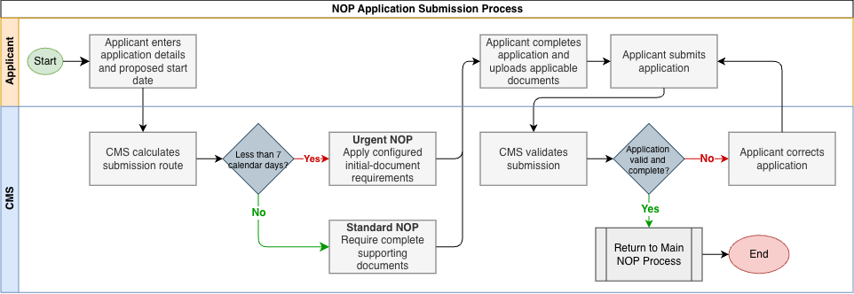

NOP Change Requested
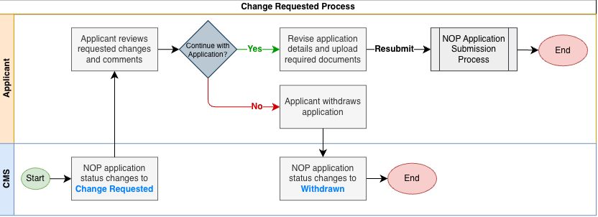

NOP In-Principle Approval
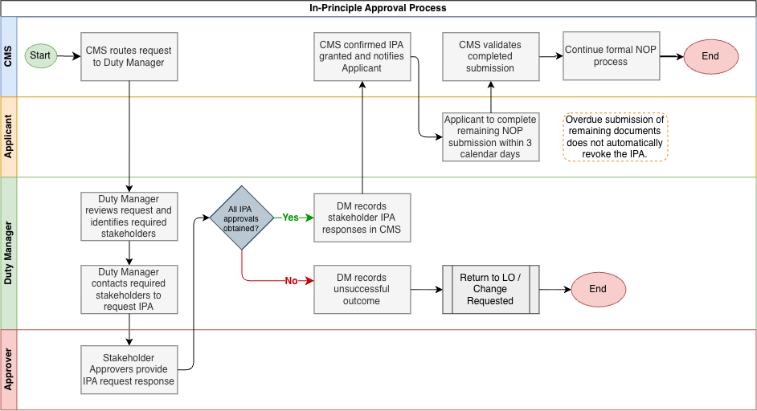

NOP Extension
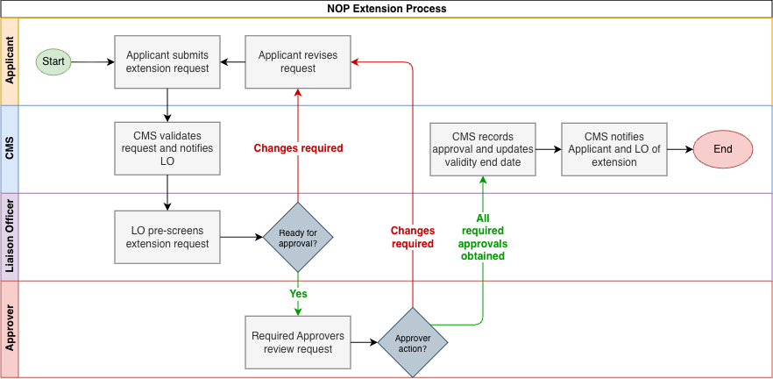

NOP Cancellation
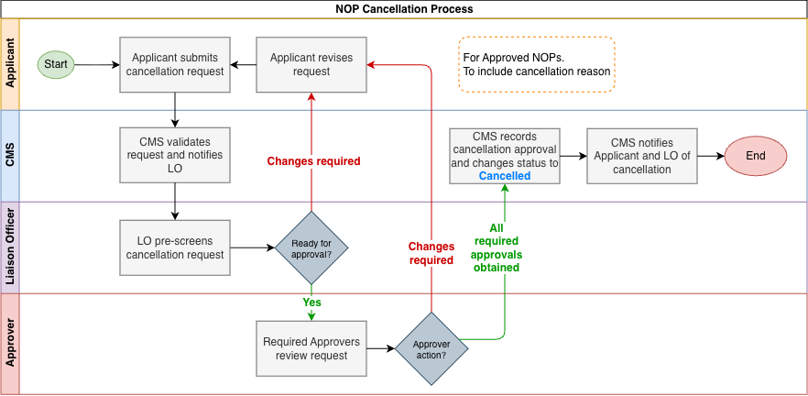

NOP Suspension, Resumption and Revocation
